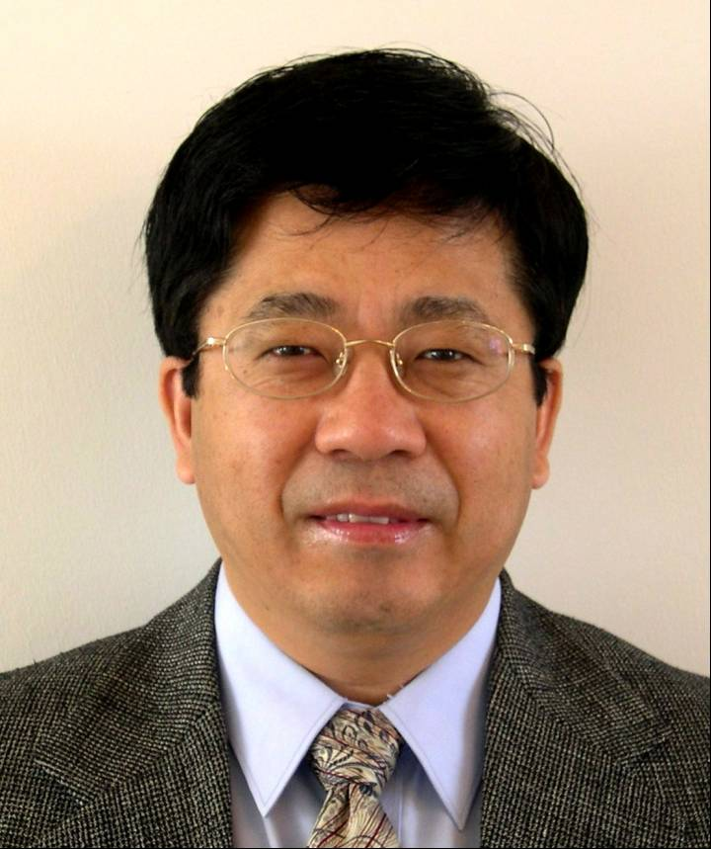
Curriculum Vitae

Yubo Yang
Abbott Laboratories, Dept. 045B
Manufacturing Sciences and Engineering, GPO
North Chicago, IL 60064-6292
yubo.yang@abbott.com
(847) 937-2316

Education Washington University
St.Louis, MO 1/1985 – 12/1988
Ph.D. Chemical Engineering, 10/1988 GPA 3.9/4.0
Thesis under Professor M. P. Duduković on “Transport-Kinetic Effects in Manufacturing of Polycrystalline Silicon”
Systematically studied and optimized the parameters for the reactor to produce large polycrystalline silicon rods via a novel design using high frequency AC, resulting in increasing yield. Formulated a process model for the seeded aerosol reactors, based on population balance of crystal particles and nucleation kinetics, for manufacture of polycrystalline silicon. Proposed a design to manufacture silicon particles (>10μm) via a series of reactors, opposed to the infeasible design by Department of Energy, saved multi-million dollars for DOE to modify the approach for the project.

Washington University

St.Louis, MO 9/1983 – 12/1984
M.S. Chemical Engineering, 12/1984 GPA 3.9/4.0
Tianjin University
Tianjin, China 9/1978 – 6/1982

B.S. Chemical Engineering, 6/1982 GPA 3.8/4.0

Professional Abbott Laboratories (CAPD/SPD/GPO)
Experience Associate Volwiler Research Fellow 9/2005 – present
GPO MS&T Process Science and Engineering
R&D Group Leader 1/2003 – 8/2005
SPD/GPO MS&T Technical Operations
Research Investigator 1/2000 – 12/2002
SPD chemical development/SPD Technical Operations
Senior Process Development Scientist 6/1997 – 12/1999
CAPD Chemical Development

Borg-Warner Research Center, Lombard, IL
Technical Specialist and Project Leader 1/1996 – 6/1997
Senior R&D Scientist 11/1994 – 1/1996
Consultant to Abbott Diagnostic Division and
MEMC Electronic Co, St.Louis, MO
Independent Consultant 3/1993 – 10/1994

Washington University, St.Louis, MO
Postdoctoral Research Associate and Research Professor 12/1988 – 2/1993
Affiliations • Senior Member of American Institute of Chemical Engineers, 1985 to present
- Member of Sigma Xi (Scientific Research Society), 2003-present
- Session Chair and Co-Chair for AIChE Conferences in 1994, 1996 and 2004
- Session Chair for AIChE Process Development Conference in 2004

Professional • Manuscript Reviewer for Industrial and Engineering Chemistry Research Journal

Activities (1987 – present) and Chemical Engineering Science (1990-Present)
- Abbott QbD API Committee Member (2010-2011)
- Manuscript Reviewer for SAE Transactions and Technical Series (1995 – 2005)
- Lecturer for Chemical Engineering Design II Class at Univ. of Illinois (2003-2007)
- Ph.D. Thesis Reviewer, Dept. of Chem. Eng., Washington University (1990-2000)
- Adjunct Professor and Member of Industrial Advisor Board, Department of Chemical Engineering, Washington University (1995-2000)
- Industrial Advisor to Chemical Reaction Engineering Laboratory at Washington University on research projects related to CARPT (Computer Automated Radioactive Particle Tracking) and CAT (Computer Automated Tomography) (1993-present)
- Member of Judge Team for AIChE Student Project Competition (1993-1996).
Awards • President’s Award, GPO, Abbott Laboratories, 1st Trimester 2010
(For novel solvent recovery and reuse in lopinavir and ritonavir processes to save multi- million dollars a year for Abbott Campoverde Plant)
- Gold Award, Abbott Laboratories, 2011 (Extrusion of Crystalline Lopinavir)
- Gold Award, Abbott Laboratories, 2010 (APL Lopinavir Transfer and Development)
- Platinum TE (technical excellence) Awards, Abbott Labs, 2007 and 2009
(For development, scale-up and validation of lopinavir FBD drying & virology expansion)
- Gold Awards, GPO, Abbott Laboratories, 2006 (for Liestal Ritonavir Trouble-Shooting)
- President’s Award, GPO, Abbott Laboratories, North Chicago, 2006
(Kaletra API production, scale-up, trouble-shooting and process robustness)
- GEHS&E Kaletra Award (Global Environmental Health, Safety and Energy)

Abbott Laboratories, 2005 (Kaletra green chemistry development and enhancement)
- President’s Award, SPD, Abbott Laboratories, 3Q2003
(Lopinavir Process 2 development, scale-up, validation, yield and throughput increase)
- All Star Award, SPD, Abbott Laboratories, 1Q2003
(Lopinavir A-Wing coupling and crystallization optimization, and for the yield increase of over 6% cumulatively in production via pyro-salt route)
- President’s Award, SPD, Abbott Laboratories, 3Q2001 (Innovation and process improvements to meet the new EP specifications of Propofol manufacturing, and for successful validation of the new process.)
- Engineering Excellence Award (Innovation/Technical Achievement), SPD, Abbott Laboratories, 2000 (For novel solution to reduce cycle time and increase throughput by >100% using the existing equipment to meet the increased commercial demands of Propofol)
- Recognition Award, CAPD Chemical Pilot Plant, Abbott Laboratories, 4Q2000 (For safety scale-up, cost and cycle time reduction of triphosgene reaction)
- Engineering Excellence Award, Borg-Warner Technical Center, 1996. (For technical innovation and excellence in process development and modeling)
- Excellent Paper Award, SAE International Congress and Exposition, 1995.
(For outstanding scientific papers in process modeling and trouble-shooting)
- Research Fellowship Award, Washington University, St.Louis, MO, 1985-1988.
- Fulbright World Bank Scholarship Award for Graduate Study at Washington University in St.Louis, 1983-1984.

Publications/Patents/Technical Reports/Conference Presentations

Activities | Career Contributions
Publications (Peer Reviewed Journals) | 18
Patent Disclosure | 3
Abbott Technical and PJ Reports | 42
Invited Speaker/Technical Presentation at Conferences | 33
Posters of Abbott Technology Exchanges | 12

